UNDERSTANDING FOCUS AND PURPOSE IN LIFE
It should not be a mystery to any believer that God’s Word is the single most important guide in life, that if followed carefully, it will bring prosperity and success. Josh 1:8 This Book of the Law shall not depart from your mouth, but you shall meditate on it day and night, so that you may be careful to do according to all that is written in it. For then you will make your way prosperous, and then you will have good success. Here the Bible is speaking about flourishing with the favorable outcome of good success. Spiritually speaking we can flourish, and as a result there will be spiritually favorable after-effects, good success. Patiently and persistently pursuing truth from God’s Word will produce results. To be prosperous and have good success, God’s Word must be actively pursued and applied, so that you may be careful to do according to all that is written in it.
Every Christian should pursue and know how to examine Scripture faithfully, and then learn how to make it practical and applicable to everyday life. Scripture was written in application form, 2 Tim 3:16, 17, and will have the noticeable effect of creating in us Christlikeness. The Bible reproduces truth in us in meaningful tangible ways. Consuming truth from the Bible, integrating truth into your life, and then reproducing truth in everyday living will bring prosperity and success. This is something that is happening within the believer who is pursuing truth. Happily, we as believers are not left to ourselves to find direction and meaning in life. Happily, we can grow in the grace and knowledge of the Lord Jesus Christ, 1 Pet 3:18, and become more like Him through His written Word. God’s glory is reproduced in us as we pursue truth, His glory becomes our earnest desire to seek and to reflect in ourselves, Matt 5:16. Understanding and focusing on God’s glory, 2Cor 3:18, explains God’s eternal purpose for us, which is understanding and focusing on God’s glory and thereby becoming more like His Son. This is often a distant thought in a believer’s heart and mind.
We want relief, we want prosperity, we want success, but without everything else that surrounds life. Most of our thinking about prosperity and success centers on the horizontal. Prosperity and success are defined in terms of how well life is treating us and how prosperous and successful we are while living life on earth. Our prosperity and success however should be viewed from the vertical dimension. My life in Christ on earth, in relationship with the Father, through the Son, by the power of the Holy Spirit, being enlightened and empowered by the Word in daily living.
In an article that was written in a secular magazine (without the Christian community in mind), 771 people responded to a survey exploring several critical life and career questions. The top eight answers sounded much like the Christian community today. The key question this survey probed was this: "If you could say in one word what you want more of in life, what would that be?"
#1 Happiness. Biggest challenge: “Not knowing what I want to do.”
#2 Money. Biggest challenge: “Not having enough money or time to accomplish the things I want to do.”
#3 Freedom. Biggest challenge: “Having the freedom to find my ‘true purpose’ or being lit-up by the day-to-day at work.”
#4 Peace. Biggest challenge: “Lack of clarity about who I am and my purpose.”
#5 Joy. Biggest challenge: “How to find the right role or position for me that will bring joy in my work.”
#6 Balance. Biggest challenge: “Balancing my need/desire for flexibility while making enough money and to have the benefits I want.”
#7 Fulfillment. Biggest challenge: “Utilizing my potential in the best possible way, for myself and for others.”
#8 Confidence. Biggest challenge: “Feeling like I have something to offer now, rather than feeling constantly as if I’m not ready and need more training.”
From this survey there were eight areas of focus, happiness, money, freedom, peace, joy, balance, fulfilment, and confidence. Then within those areas of focus, their purpose was referred to as the biggest challenge. Things like accomplish, true purpose, clarity, joy in my work, balancing need/desire, utilizing potential, having something to offer, defined purpose. This survey was not just about work, it was about how people look at life horizontally, without the benefit of couching the horizontal life within the vertical dimension of a relationship with God, without the primary focus upon God. As a believer our relationship with God defines all of the eight areas of focus, because it finds all of them in Him. Unfortunately, the Christian community too often views life in the same manner, neglecting to see God in the top eight answers.
The question in the survey was: "If you could say in one word what you want more of in life, what would that be?" The one-word for the believer would be God, but more specifically God’s glory. That “want” for God and His glory leads believers to the most satisfying purpose in life. God is glorified in our single purpose in life being fulfilled when we become more like His Son. Our happiness, money, freedom, peace, joy, balance, fulfilment and confidence are couched in God’s plan for our life, in God’s sovereign rule over our lives, in what God has to say about our focus and purpose in life. It defines Matt 6:33 for us, as well as adding all the other eight things that unbelievers seek without pursuing God.
Unfortunately, many believers’ focus and purpose in life is not clearly defined or anchored in a biblical philosophy of living life as God intended, because not enough thought has been centered on pursuing God through His Word. As a result, life is unsettled when happiness, money, freedom, peace, joy, balance, fulfilment, and confidence are not apparent, or are being challenged, or nonexistent. Life becomes a challenge when focus and purpose in life is not clear. This happens when the things mentioned in the survey are the focus and purpose of life, rather than pursuing and pleasing God by becoming more like His Son. When everything in life is aimed toward the horizontal and temporal, and things faulter or fail, life follows suit. When we are not satisfied in God Himself, life becomes harder and harder, we often then seek God replacements, our own pursuits.
We fail people when we do not help them to understand God’s focus and God’s purpose in life. Because of this, I use a visual aid to make it easier for counselees/disciples to understand God’s focus and purpose for life. Without it, Christians will focus on circumstances, or struggle with the question of life’s focus and purpose. They will fail to benefit from the full impact of the gospel in their lives, they will sink down into the mire of problems in life. Believers are susceptible to being dragged down into struggles when they have no understanding of focus and purpose in life.
Because Scripture reaches the inner man at the heart level, Heb 4:12, and is where true transformation and testing takes place, 1 Thess 1:4, we teach with confidence Jesus’ philosophy of living, Jn 8:28, 29, so that the believer can confidently know “how to walk and to please God”, “more and more”, 1 Thess 4:1. We seek God’s glory in whatever we do, 1 Cor 10:31, are confident in God’s unchangeable purpose of conforming believers into the image of His Son, Rom 8:29. This is the answer to life stability, life fulfillment, and the full effects of the gospel in one’s life. The Scriptures bring us to these conclusions, they give us comfort and peace as well as understanding. They are sufficient for all of life and godliness 2 Pe 1:3,4, not some of life, but all of life. We must believe this and be confident in the sufficiency of Scripture as counselors. This is the singular ultimate focus & purpose in life.
THE PLEASE GOD CHART
This chart describes the fundamental platform for counseling/discipleship in two words, Focus and Purpose. The Focus is to please God by bringing Him ultimate glory, and the Purpose is to be conformed into the image of His Son. How do we say this in one sentence? To please God by bringing Him ultimate glory through becoming like His Son. Believers should gain great confidence and hope in this, because God is most glorified when we reproduce His Son in our lives. If a believer has this kind of confidence and hope, they can grow in their understanding of how to handle issues that are present in their lives. Presenting this chart in a counseling/discipleship session brings hope, clarity, and direction in life. Establishing hope early and often in counseling is of great importance.
Again, Focus and Purpose are the two key words that we want to emphasis as basic and central focal points in the Christian’s life. We are saying that pleasing God by bringing Him ultimate glory is the Christian’s ultimate goal or focus in life. We are saying that the Christians ultimate purpose in life is being conformed into the image of God’s Son Jesus Christ. The Christian’s task is to strive to become more like Christ and thereby please God, because it is Christ in whom God was well pleased, Matt 3:17. This is what Paul had in mind when he wrote, Col 1:9 And so, from the day we heard, we have not ceased to pray for you, asking that you may be filled with the knowledge of his will in all spiritual wisdom and understanding, 10 so as to walk in a manner worthy of the Lord, fully pleasing to him: bearing fruit in every good work and increasing in the knowledge of God;
Pleasing God by bringing Him ultimate glory through becoming like His Son is the ultimate focus and purpose in life. When the Father said, “This is my beloved Son, with whom I am well pleased.” Matt 3:17, it pinpoints the fact that becoming more and more like Christ pleases the Father as He sees His Son in us. Jesus’ death was substitutionary; He became sin for us and took our place, 2 Cor 5:21, and now our life is in Him, Col 3:4, Gal 2:20. God is glorified as Jesus’ life is revealed more and more in us, as He increases and we decrease Jn 3:30. This is God’s kingdom purpose, and if we seek it first, everything else we need in life will be added, Matt 6:33. Everything in life is made up of goals and tasks in some way. Life is a series of conscious decisions we make to accomplish something in order to gain something. People who live with no goals in life really have no direction in life. We want to help believers to understand God’s goals and God’s purpose in life. Is it important for believers to have focus and purpose in life? Yes! This is truly a lost emphasis in church ministry, it is a lost emphasis in growing disciples in the local church. It should be a primary emphasis in preaching, teaching, and counseling, as a major focus and function of local church ministry.
There are times when a person can only focus on one thing at a time because of what they have experienced or are experiencing presently. If we can get a counselee to focus on the two words, Focus and Purpose, in times of trouble, confusion, heightened anxiety, fear, anger, abuse, mistreatment, or what have you, we will help them to stabilize early in our sessions. If our counselee is too traumatized or is not able to maintain focus because of their circumstances, just having them think about and remember the two words, focus and purpose, is stabilizing, hopeful, and assuring. I have seen many counselees who have found peace and stability in an otherwise upside-down world and begin to stabilize by focusing on just these two words, as well as hanging on to these two simple passages, 1 Cor 10:31 and Rom 8:28, 29. The ugliness of life becomes manageable and understandable when we turn to the sufficiency of Scriptures for all of life and godliness, 2 Pet 1:3,4. Starting with two simple words and two simple passages will have an immediate effect, and produce fruit over time as you work with God’s people.
For most cases, introducing this chart in the first session will set the stage for all the other sessions in the future. How and when it is appropriate to introduce the Please God Chart under differing circumstances is important to consider. Timing is critical when applying truth in every circumstance. Being wise and walking with a person as you teach them this chart is essential to its effectiveness. Depending on the counseling situation, it may take time to introduce why a believer’s proper focus and purpose in life is important. The counselee may have gone through traumatic experiences, so thinking through the chart with clarity and understanding would be better accomplished later, or in smaller increments. Wisdom and discernment on our part will help with the appropriateness of timing to introduce the chart. Eventually, in every circumstance the chart, will help a person with focus and purpose in life. Every counselee has a future to deal with; we want to establish hope through difficulties in life now, as well as leave them with hopefulness as they enter the future.
KNOWING OUR GOALS ARE CHRIST’S GOALS GIVES US DIRECTION
Let’s place some greater emphasis on the importance of having Focus & Purpose. In everything we look to Christ as our ultimate model. He is the model of what focus, and purpose should look like in life. Jesus’ life on earth gives us the clearest example of how He lived as a goal-oriented person. Many are frustrated by being told or taught what to do, without knowing how to do what they are being told or taught. A person hears what they must do and rightly responds by wondering how they will go about doing it. If we are not careful, we will frustrate people who are responding to truth by not also teaching them how to reproduce that truth. “Many are good at explaining the (what to) of a passage but are quite defective when it comes to suggesting how to.…….. Jesus’ Sermon on the Mount in Matthew 5–7 teaches us the importance of helping people to implement truth. After the beatitudes and the general comments on salt and light, Jesus showed his listeners how to implement all the subsequent commands, (what to do), then He gave them a model on (how to do). Your counselees will come alive and then grow rapidly when you show them how to implement biblical truth. What to do and how to do are very important, simply one must know what they are supposed to do with their lives and how to go about doing it, or they will become frustrated. More will be said about the what to do and how to do of prioritized living later, but here we will see Jesus as the model of knowing what to do and how to do it. His life was focused, and He knew how to live His purpose in life to the fullest. Jesus models both the what to do and the how to do of everyday living. He describes in the two verses below His focus, what to do, and purpose, how to do, as a philosophy of living life.
John 8:28 So Jesus said to them, “When you have lifted up the Son of Man, then you will know that I am he, and that I do nothing on my own authority, but speak just as the Father taught me. 29 And he who sent me is with me. He has not left me alone, for I always do the things that are pleasing to him.”
The Lord Jesus’s task led to the ultimate goal in His life, which was to please and glorify the Father. “I always do the things that are pleasing to him.” This describes His goal, or what to do. We call this Jesus’ philosophy of living, and His life exhibited the task, how to do, by action, “I do nothing on my own authority, I speak just as the father hath taught me“. There must be a way to reach the goal of pleasing God, and Jesus perfectly models how this is done, following what He was taught by the Father, which resulted in always doing “the things that are pleasing to Him”. The implication to us is that Jesus learned and then applied what the Father taught Him in His everyday life. He was able to please the Father, which was His ultimate goal, by doing the things the Father had taught Him. Learning then applying truth. Jesus left us a model to reflect upon and reproduce.
This is a fascinating thought and provides a clear understanding of how Jesus kept the goal of pleasing the Father in mind at all times. He then followed through with a task to reach that goal, which was to do the things the Father had taught Him. This is clearly not being performance oriented; it is a philosophy of living; it is a focus the Lord had each day. You must do something to reproduce this philosophy of living, the how to do in everyday life is becoming more like God’s Son. This should be a goal of ours every day, this is not being performance oriented this is being biblically oriented. We are not asking people to do something without knowing the reason why, the what to do, so that they can and should reproduce truth, the how to do. We emphasize that we cannot do truth on our own, we emphasize that it is Christ in us that helps us to become like Christ in order to please God. Practicing truth is not a foreign teaching in the Bible and is not being performance oriented. When a person realizes that it is Christ in them, by the Holy Spirit, through His Word, that is actually doing the work through them, it is inspiring and encouraging to say the least. It is a relief to know that the Christian life cannot be lived alone, it must be lived through Christ. Phil 2:13, 1 Tim 4:7, Heb 5:14, 1 Jn 1:6. I read where someone said, “Pleasing God is not about what you do, but about resting in the only One who could please God”. But the Christian life is an active type that includes actively resting and placing our trust in Him, by not only believing, but hoping and resting in Him. We are actively reproducing our faith in how we live life. “The Christian life is a life of continual change. In the Scriptures it is called a “walk”, not a rest.” There is no resting in God when there is no active faith producing the outward action of a resting faith. We are not trying to help a person to feel more spiritual or give someone a list of things that would please God if they would do them.
This is where we develop and understand focus and purpose in life, through the example of Christ. 1 Pet 2:21. To restate how we convey this message clearly; we are saying that we please God by bringing Him ultimate glory through becoming like His Son. Becoming like God’s Son in specific, meaningful, and measurable ways pleases God and brings Him ultimate glory. This gives direction in life, this helps the husband understand how to love His wife as Christ loved the Church, it helps the believer to reproduce Christ in their actions, Jn 13:17, it leads into an attitude of giving others our ultimate best, 1 Jn 3:16, as “imitators of God”, reproducing “how to” walk in love, Eph 5:1,2. All of this, and much more, is a measure of becoming more like God’s Son, 1 Jn 2:6. None of this is being performance oriented, it is becoming like God’s Son. To the degree that we reproduce biblical truth in our lives, to that same degree are we becoming like God’s Son in our everyday life.
This should be the ultimate model for us to follow, focusing on pleasing God by fulfilling the Father’s purpose, by becoming like His Son. Jn 8:28 So Jesus said to them, “When you have lifted up the Son of Man, then you will know that I am he, and that I do nothing on my own authority, but speak just as the Father taught me. 29 And he who sent me is with me. He has not left me alone, for I always do the things that are pleasing to him.” The Father would say of His Son, “This is my beloved Son, with whom I am well pleased.” Matt 3:17, Jesus’ life pleased the Father and brought Him ultimate glory. Reaching the goal of pleasing God and bringing Him ultimate glory by accomplishing a task is exactly what Jesus always did, and what He ultimately did when He died on the cross for God’s glory. John12:27 “Now is my soul troubled. And what shall I say? ‘Father, save me from this hour’? But for this purpose I have come to this hour. 28 Father, glorify your name.” Then a voice came from heaven: “I have glorified it, and I will glorify it again.” 29 The crowd that stood there and heard it said that it had thundered. Others said, “An angel has spoken to him.” 30 Jesus answered, “This voice has come for your sake, not mine. Jesus lived a life that glorified the Father, for our sake He lived and died to please the Father. Believers must do the same, by following His example, and not wandering aimlessly through life wondering what to focus upon, or where ultimate purpose in life resides. Jesus did not wander aimlessly through life, and neither should we, establishing focus and purpose in life is reassuring, confidence building, uplifting, inspiring, and full of hopefulness. The question is, do we have this focus ourselves as counselors, and how does this focus actively and purposely function in our everyday lives?
PLEASING GOD BY BRINGING HIM ULTIMATE GLORY WAS MODELED BY THE APOSTLE PAUL
Paul wrote, “So whether we are at home or away, we make it our aim to please him.” 2 Cor 5:9. There is no doubt that Paul adopted the Lord’s ambition of pleasing God in His life as a goal as well. Paul made it his ambition or “aim”, the task, “to please Him”, his goal. Paul states that his ambition, his motivation, his goal, is to be accepted of Him, to please Him, to bring Him ultimate glory in everything he did, 1 Cor 10:31. We could then say that Jesus, Paul, and a host of others in the Bible lived focused lives. Pleasing God is the basis of our faith, Heb 11:6, And without faith it is impossible to please him, for whoever would draw near to God must believe that he exists and that he rewards those who seek him. It is man’s chief end, 1 Chron 16:29 Ascribe to the Lord the glory due his name; bring an offering and come before him! Worship the Lord in the splendor of holiness. Paul’s model is well documented throughout the New Testament; his life was a life given over to God’s glory. Believers should consider their lives given over to God’s glory just as Paul did in following the Lord’s example, 1 Pet 2:21.
FOCUS AND PURPOSE EQUALS SPIRITUAL GROWTH
The reason that spiritual growth is either nonexistent or sporadic in a believer’s life is typically because a believer has not established a biblical understanding of focus and purpose. Without focus and purpose, the spiritual life is vulnerable, and therefore susceptible to every kind of sin issue, and every sort of human disfunction associated with our sinful broken condition. Focus and purpose in one’s life addresses every issue of life because every human being deals with sinful brokenness, either by sinning or being sinned against, as well as missing what our focus and purpose in life really should be. We want to instill hope and provide stability in our counseling by assuring our counselee that God has a plan and purpose for them. The journey they are on now should be moving them in that direction. God has a purpose for them, God has a goal for them in life. A life that is stagnant is lifeless, meaningless, and vulnerable.
Helping a person regain a proper focus and purpose in life establishes great confidence and hope, something every counselor should do in the first session, and continue throughout the sessions. Every Christian can please God and bring Him glory by becoming like His Son, this is the greatest confidence and hope-building truth in the Bible. Because this is within the design of God’s eternal purpose for every believer when God saves us, He is glorified by recreating His Son in us, in whom He is “well pleased” Matt 3:17, and as a result, we can live “to the praise His glory”, Eph 1. This is the essence of spiritual growth, God’s glory through becoming like His Son, this is the greatest confidence and hopeful truth that you can bring to the table.
People want to have a clear goal in life and want to understand how to reach that goal - they want to understand how to become like God’s Son in the difficult parts of life. They want to understand God’s design in trials and abuse or ill-treatment. Whether they are a victim of a terrible experience, or they are the victim of their own circumstance, they need clarity and direction in life. Life has focus and purpose because all of life fits within the sovereignty of God. God can be glorified in and through our lives, in every circumstance of life, in every part of our lives, when we focus on His design for our lives.
THE GLORY OF THE GOSPEL IS ALREADY IN US
The emphasis of the gospel is Christ in us, the hope of glory, Colossians 1:27 To them God chose to make known how great among the Gentiles are the riches of the glory of this mystery, which is Christ in you, the hope of glory. The believer should know that they are fully equipped to please God because of the gospel. Jesus was focused on God’s glory, and this was the catalyst for His actions. Glorifying the Father through the action of dying on the cross is a valuable lesson for us. As Jesus’ ultimate model of living to please God brought God ultimate glory through the purpose/act of dying on the cross. The gospel then is all about God’s glory and we are the recipients of the richness of this glory through the transformational effect of the gospel. If a believer understands the importance of focus and purpose, they will have a deeper understanding of the significance of God’s glory in the gospel in which we are recipients. The gospel transforms and empowers us. “The Bible indicates that, outside of heaven, the glory of God in its thickest density dwells inside the gospel. It is for this reason that the gospel is described in Scripture as “the gospel of the glory of Christ” and “the gospel of the glory of the blessed God.” 2 Cor 4:4, 1 Tim 1:11. “Clearly, the gospel generated in Paul an enormous passion for God’s glory; and the gospel does the same in me as I make it the meditation of my heart each day. Understanding that I am not the ultimate end of the gospel, but rather that God’s glory is, enables me to embrace my salvation more boldly than I would otherwise dare to do.” We must embrace our salvation as instruments of God’s glory and live that glory out through the gospel that is already in us, that has transformed us into a new creation and is day by day transforming us. 2 Cor 4:16 So we do not lose heart. Though our outer self is wasting away, our inner self is being renewed day by day. The gospel must become more personal and its claims upon us must be owned and reproduced in our lives. What hope this brings to the counselee, we are transformed and empowered by the gospel! Remind your counselee of this often.
EXPLAINING THE POWER AND TRANSFORMATIONAL EFFECTS OF THE GOSPEL
Change in our lives is possible because God first changed us in Christ, 2 Cor 5:17. Change must originate from the heart level, Prov 4:23. Gospel truths should be taught as practical, attainable tasks that reproduce truth by spiritual exercise, thereby producing confidence in the believer that he is pursuing God’s purpose for his life, becoming like His Son. Gal 4:19; Phil 3:14, 15; 1 Tim 4:7-8. A counselee must see truth applied practically not academically.
God’s sufficient Word, 2 Tim 3:16-17, produces the ability to change and please God by the renewing of the mind, Rom 12:2, Eph 4:20-32, Col 3:4-17. The counselee will begin to experience in his heart a consistent advancement towards godliness by the power of the Word, Heb 4:12, 2 Pe 1:3-9 3. Reaching God’s goal will become a reality, and God will be pleased by seeing Christ formed in them Gal 4:29, in daily spiritual growth and maturity, 2 Pet 3:18. Explaining this to a counselee is significant because it continually encourages them and gives hope.
From what you have learned thus far, the believer must have just one thought in mind as a motivating factor for change, a singular motive, which is to change for the glory of God. 1 Cor 10:31 Here we can ask a question about choices. Is the decision to change or the decision to choose to remain the same going to bring ultimate glory to God? A choice must be made, which one pleases God? Because a choice is being made it is critical that you contemplate the outcome of your choice. This decision will reveal the heart at the motive level. It answers the question about heart motives and where their heart is focused in the choices they make. If there is no change then there is no growth. Track your counselees spiritual growth, be sure to guard against behavioral change without spiritual heart transformational change that can only be brought about by Scripture.

EXPLAINING THE CHART
- Notice the chart on page 10, it has two black lines dividing the chart into three horizontal sections. The top of the chart emphasizes God’s glory as the focus in life. (The what to do) The center section emphasizes God’s eternal purpose for us in life, conforming us into the image of His Son. (The how to) The third and final section on the bottom of the chart, explains how the heart becomes vulnerable when there is no Focus & Purpose in life, or the wrong Focus & Purpose in life.
- Starting at the top left-hand corner of the page you will read in box #1 FOCUS, Pleasing God by bringing Him ultimate glory”, 1 Cor. 10:31. Here is where we want to establish the most important factor in the Christian’s life, to please God by bringing Him ultimate glory. Establishing pleasing God by bringing Him ultimate glory is the single most important factor in a believer’s life. Nothing is more important. It is the fundamental principle in which all else is determined upon in life. Both verbs "do" are in the present tense which calls for us to live a life that continually brings glory to God.
“Paul’s central message in this passage, and the Bible’s central message for believers in all ages, is summarized in verse 31: whatever you do, do all to the glory of God.” “Paul is saying that even in the most mundane, routine, nonspiritual things of life, like ordinary eating and drinking, God is to be glorified. His glory is to be our life commitment. It is the purpose of our whole life, which now belongs to the Lord because we have been “bought with a price” 1 Cor. 7:23.” “My conclusion is that God’s own glory is uppermost in His own affections. In everything He does, His purpose is to preserve and display that glory. To say that His own glory is uppermost in His own affections means that He puts a greater value on it than on anything else. He delights in His glory above all things.” “God’s ultimate goal therefore is to preserve and display His infinite and awesome greatness and worth, that is, His glory. God has many other goals in what He does. But none of them is more ultimate than this. They are all subordinate.” We must conclude that to teach as a central focus pleasing God by bringing Him ultimate glory is of utmost importance and should be the driving philosophy for everything we do as believers and in ministry.
- Moving right to the center box #2, read the Scriptures as well as ask and answer questions about what Scripture teaches about God’s glory. Many other passages about God’s glory could be included in that discussion. Ask if they understand God’s glory as the main focus in Scripture. Ask questions that draw out their understanding of God’s glory. Ask, has this been a focus in your life? Have you thought about this before? Can you explain what this means?
- Ideas on how to communicate this part of the chart by explaining a biblical focus in life.
Life Focus and Pursuit. Take time to explain how life focus, motive, and pursuit, flows from the heart, Prov 4:23. To know God is to know what pleases Him, to know what motivates Him, to know what His ultimate goal is, the thing that He most desires that drives His actions - to know that He created all things for His glory, to the praise of His glory. All things are for this express purpose. Is 43:6,7, John chapters 11-21, Ro 8:18, Ro 11:36, 1 Cor 6:20, Eph 1:5,6, 1 Pe 4:11, Rev 4:11, 5:12,13. Seeing God’s glory in Christ, in creation, and in us is God’s ultimate goal for us in life. Pleasing God by bringing Him ultimate glory should be a daily pursuit, a goal for every believer. 1 Cor 10:31; Gal 1:10; 1 Thess 4:1; 2 Tim 2:4. God’s glory is not only a daily pursuit, but a daily focus. Ps 115:1, Matt 6:33; Col3:1-3. Where is our focus? What is our focus? Stop and think about where your focus has been. Now, what has been your life’s focus, or do you have a life focus? See: 5c Change or Application 1.docx
Establishing Hope. Do you know that God has enabled us to bring Him ultimate glory through the gospel? Explain to them that God has enabled us to glorify Him by specific, concrete, and measurable focused growth in Christ because of the gospel. The gospel is life in us, it is God’s glory in us, 2 Cor 4:6. It is the hope and glory of Christ in us, Col 1:27. Everything in life is for the PURPOSE of conforming us into the image of God’s Son for His glory, Rom 8:28-29; Ephesians 1:9-12; 2 Pe 3:18 The task then is to move our lives toward pleasing God, FOCUS, by becoming more like His Son, PURPOSE, in meaningful measurable ways, thus bringing about great confidence in Christ within me. He is the One who is doing His work in and through me.
- As an Attitude of the Heart. When the attitude of the heart is focused on pleasing God by bringing Him ultimate glory, by fulfilling God’s purpose of becoming like His Son, His glory is reflected in you. The attitude of your heart will change because your focus will change. Jesus’ reflection in you becomes an attitude of the heart that is full of delight in God’s glory, and it is reflected in your Christlikeness. It reveals God’s work in you that glorifies God. Matt 5:16, Phil 1:9-11. A proper attitude of the heart that focuses on God’s glory, as well as seeking to become like God’s Son, strengthens one’s attitude towards life.

- Understanding how to glorify and please God from the heart begins:
When we recognize the centrality of our hearts in knowing, worshiping, and pursuing God, life takes on a completely different meaning. Matt 6:21, Prov 3:5, 6; 4:23.
When we understand that God is and has made us to be goal oriented like Him, we become better stewards or managers of our lives. 1 Cor 9:24, Ephesians 5:16, Phil 3:1-16, 2 Tim 4:6-8
When we recognize that God is most glorified when we are most satisfied in Him, our satisfaction with life changes. Phil 1:20-23
When our ultimate satisfaction is having our deepest desires centered on Him, our pursuits in life change. Ps 37:4; Mk 12:30
When our highest pursuit in life is focused on the maximum pursuit of God, that brings the greatest amount of glory to God, our satisfaction with life increases. Heb 11:6
When His life is preeminent in ours, we are “fully pleasing to Him” Col 1:9-19. As the Father bore witness of His Son, “with whom I am well pleased” Matt 3:17, Christ in us is pleasing to the Father, a reflection of the Father’s eternal purpose of us becoming like His Son, Rom 8:29.
God’s desire is captured in our understanding of focus and purpose in life; God’s desire becomes our desire. God’s desire is captured in our understanding of focus and purpose in life,1 Cor 10:31; Rom 8:28-29; Rom 12:1,2; Eph 1:4-6, 11-14. He is glorified in His Son being formed in you, Gal 4:19. When this becomes your desire, God is glorified in and through you.
- Continue moving to the right top of the page box #3. The question is, how does a person reach this goal? How am I growing in meaningful measurable ways, and confident that I am pleasing God 2 Pe 3:18”? If this is God’s desire for me, how do I do that? This is where you can talk to the counselee about their frustrations, sense of guilt, sense of no direction or accomplishment in life, being performance oriented, or wandering aimlessly through life without a proper focus.
- Moving to the left middle section, box #4, explains PURPOSE in life. This is where we explain the process of progressive sanctification, or spiritual growth into the image of Christ. Here you can discuss the dilemma that many Christians find themselves in when they wrestle with the, what to do and the how to do of life. They either don’t know what to do with their lives or are frustrated over how to do something in life. When this frustration is met with an understanding, and a simple plan on how to go about pleasing God by bringing Him ultimate glory, we are establishing hope and direction for this person’s life.
The model of how our Lord accomplished both the, what to do and how to do of life is important to explain using Jn 8:28,29. Notice in box #2 (What To Do) and in box #4 (How To Do). Jesus knew what to do to glorify and please the Father, and He knew the how to do, how He was going to accomplish the task of glorifying and pleasing the Father. There was not a question about focus or purpose in His life. His example is left for us to follow, 1 Pe 2:21. Jesus had proper focus and purpose in life. Those two words, Focus and Purpose, should resonate in the hearts of those we are working with, because without the right focus and purpose in life we have no direction in life. Jesus’ desire to glorify the Father implies Jesus was taught, which resulted in always doing “the things that are pleasing to Him”. Jesus learned and then applied what the Father taught Him in His everyday life. The Father was ultimately pleased and glorified. If we are to follow this example, then at the forefront of our minds should be our Focus and Purpose in daily life. Are you focused on pleasing God by bringing Him ultimate glory today, is your purpose today to become like Jesus in a meaningful measurable way? We are helping with frustration in spiritual growth, as well as direction, hope, and confidence that they can grow in Christ in meaningful measurable ways.
Point to the middle of the chart, “Am I growing in meaningful measurable ways, and confident that I am pleasing God? 2 Pe 3:18”. We are asking them how they are accomplishing the task of pleasing God by bringing Him ultimate glory with their lives. Usually, folks have no idea of how to grow in Christ. This is a great place to ask questions about spiritual growth. They may not understand how to grow and change in Christ, we want to enter into their lives here and partner with them, we want them to understand how to grow in Christ. Explain spiritual growth and give illustrations of what that should look like in a believer’s life. If this is God’s eternal purpose and He is going to accomplish this “until the day of Jesus Christ”, Phil 1:6, encourage this kind of confidence and ability.
The middle section of the chart is an explanation of the transformational effects of the gospel. The gospel brings you into a relationship with God through Christ, you are now positionally sanctified in Christ. Now your life will continually or progressively be sanctified and transformed into His image through His Word as you seek and grasp truth. This is how we can please God and bring Him ultimate glory. We are again emphasizing that this is not something we do on our own, we are not encouraging being performance oriented, we are becoming like Christ, and as a result, we have the ability to reproduce biblical truth. Read through the Scriptures cited and explain. Have them ask questions and answer questions about Christlikeness. Encourage them with God’s promise to conform them into the image of Christ.
- Pointing to box #5 on the far right of the center. Here we want to encourage them again. Help them to be encouraged that focusing on pleasing God and bringing Him ultimate glory is God’s saving purpose. Emphasis to them that they have the ability in Christ to do so, Eph 2:10. God has enabled us in Christ through salvation to reach the goal of pleasing Him, 1 Thess 2:12. The task is to grow in Him specifically and diligently in concrete, meaningful, and measurable ways and they can do it. We can understand how we are becoming like God’s Son; spiritual growth is measurable and possible. Explain how God’s eternal purpose, Phil 3:8-11, 2 Cor 3:18, is being fulfilled in them in every circumstance in life. Make this part practical.
Point to box #5 again. Notice the three principal areas of life, Home, Work and Church. These are the three principal areas of life that we live. We all need to grow in these three areas of life. God’s purpose is to conform us into the image of His Son and that is not done overnight. “The faith that pleases God goes well beyond salvation. God is pleased by a vigorous faith that is operational moment by moment. God-pleasing faith lives life with the conviction that God keeps His promises—both in this life and the next. The one whose faith pleases God does not just “believe that He is,” but also, “that He is a rewarder of those who seek Him” (Hebrews 11:6, emphasis added).” A believers’ spiritual life should not be stagnant, it should be a vigorous growing faith, moving forward, becoming more like Christ.
It is fair to ask the question, how do I move from where I am to ultimately pleasing God and bringing Him ultimate glory with my life? We do this by progressively becoming like God’s Son in every area of the three principal areas of life. Explaining how growth is progressive, we are emphasizing spiritual growth as gradual, increasing, consistent, and continual. This is important, because everyone is progressively growing into Christlikeness, it isn’t an overnight, “bang”, I finally made it, or a discouraging, “I will never be able to please God”. We want people to know that it is ok if there is slow growth, as long as they are growing. Here is a great place to encourage and motivate the counselee to realize that spiritual growth is gradual and that we are also gradually changing in areas of our own lives. Speak to them about spiritual growth, ask them where they think they are in specific areas of their lives, where they live in those three principal areas of life.
Using the chart in the back of this lesson, (1c Please God Chart Demonstration.docx), make a horizonal line at the bottom of the arrow, then stack a few lines above like a ladder on the arrow in the middle. Point to “pleasing God by bringing Him ultimate glory” at the top of the arrow. Point to the bottom of the arrow where it says “me”. Use the lines to show gradual spiritual growth upward toward pleasing God. Here is where we explain how growth is progressive, from the bottom moving upward toward the goal of pleasing God in specific areas of my life. We are emphasizing spiritual growth here. This helps believers to visualize progressively how the Lord is working in them. Use your own progressive spiritual growth as an example, places where you are growing in areas of your life. This can also be drawn out on paper as illustrated in, (1d Power point please God Chart Demonstrations.docx), also at the back of this lesson.
Take time to explain how Christ is formed in the believer. Gal 4:19. Truths that you learn as a disciple are taught as practical attainable tasks, ways you plan in your life to reproduce truth by spiritual exercise and confidence in God’s only purpose for every believer. Phil 3:14, 15; 1 Tim 4:7-8 God’s sufficient Word 2 Tim 3:16-17, produces the ability to change and please God by the renewing of the mind. Rom 12:2, Eph 4:20-32, Col 3:4-17, and begins to daily work in your heart to produce a consistent life toward godliness. Heb 4:12, 2 Pe 1:3-9 3. Reaching God’s goal for you becomes a reality, and God is pleased by seeing Christ formed in you by daily spiritual growth and maturity. 2 Pe 3:18
Pick a subject like anger, fear, worry, or depression and show them how they can grow in meaningful and measurable ways toward the goal of pleasing God. Let them know that spiritual growth is progressive. There are some that are in different stages of growth in areas of their lives, which is normal, others may be further along, but we are all growing together at different levels. One that is ahead in their growth helps the one who is a little farther behind, but we are all growing in areas of our lives. Be encouraged that the goal and purpose of growing in Christ is possible in every area of life, in the three principal areas of life.
Because the majority of our lives are found at are home, work, and church, we want to ask questions about each of them. Note statements made by your counselee about these three principal areas of life. Here you may begin to see a pattern of motivation for change, or non-motivation to change. Here you can discern certain attitudes of the heart when asking questions about each area of life.
There are hundreds of people who are not becoming more Christlike, because they have not given attention to specific areas surrounding these three principal areas of life. Take time to walk through these areas of life and ask questions. For instance: “do you get along with work mates, Sally?” “Yes, and my boss is great.” “Well, what is the difference in your relationship with your husband James?” “You also said that you get along great with people at church. What differences do you see in these relationships compared to your relationship with your husband?”
Many believers have not learned to internalize spiritual truth and then reproduce it in their lives. They are either performance oriented, have fear of man issues, or experience other nonbiblical motivational forces. Personal change and development originate from the spiritual change of becoming more like God’s Son, “doing something” is a response to becoming like God’s Son, not just for the sake of “doing something”, but because the desires of the heart are changing. For instance, a person is now more like Christ in how they manage their life circumstances, because of becoming more like Jesus Christ in specific areas of their lives. Their heart is experiencing a noticeable desire to be like Jesus. Their response to life around them is different, there is a continual pursuit to glorify the Father by becoming like His Son. There has been a definite “inner attitude of the heart” change. Their heart’s attitude and response to life is more Christlike in the three principal areas of life. The desires of the heart are different, and you notice meaningful, measurable spiritual growth toward Christlikeness, 1 Tim 4:7, 8.
This is important because the knowledge that God’s goals are also our goals: 1. Gives us confidence. 2. Gives direction for daily decisions. 3. Focuses our energy & life with real meaning. 4. Produces faithful obedience. 5. Helps with wise use of spiritual gifts. 6. Provides a yardstick for evaluation.
- Box #6 may or may not be applicable for your counseling situation because you may not be directly dealing with a sin issue in a counselee’s life, they may be a victim of being sinned against or may be a person who just needs to understand life focus. You can end your discussion of the focus and purpose chart here, or you can continue to Box #6.
Continuing from box #6, you will move down to the box below containing three important characteristics of the heart of man. Here we are helping the counselee to see how an unguarded heart becomes a defiled heart that leads to a deceived heart, which sets up idols of the heart. A counselee asked me once, “why do I keep on doing this?”, and the answer is in this portion of the chart. An unguarded heart leads to defilement and deception, and the setting up of idols in the heart. Sin encroaches upon the heart and eventually becomes a destructive ruling idol of the heart. There are many different ways to discuss how sin becomes a deceptive, controlling, God-replacing evil in one’s life. This should have a great impact on the thoughts of the heart of the counselee. They should feel threated by the immensity of sin’s grasp on their lives, as well as the immense need to repent from the sin that is in their lives.
So, what happens when our hearts are not focused on pleasing God by bringing Him ultimate glory? Vulnerability. People need to see how an unguarded heart brought them to the place that they are today. This can apply in different ways to different circumstances. If a person is a victim or is not sure how they fell into the darkness of depression, this box affords an opportunity to explain how everything in life connects at the heart level. This is an excellent way to introduce parts of the Heart Study, (Heart Homework 1.docx). Explain how everything in life flows from the heart. The heart is the control center for behavior, speech and actions.
Following the arrows over to box #7, here we examine what happens to an unguarded/defiled/deceived heart. Moving from the top to the bottom of box #7, read what an unguarded heart creates within a person. Discuss each point and then move down to the self-focus section of the box. The unguarded heart eventually becomes self-focused. Review each point in the context of the counselee’s life. Usually, this section is revealing to the counselee. It often breaks through hard-heartedness and pride. When a person sees that they are worshiping something other than God, especially themselves, it is revealing. God replacements that are idols of the heart exist in a variety of ways. We want folks to see idols of the heart so that we can help them to confront those idols and grow in their understanding of repentance and change. This is a great place to identify idols of the heart and deal with them before God in repentance. It is helpful to the counselee to be specific in this area of identifying idols of the heart.
Theologian John Calvin was right when he said that, by nature, our human hearts are “idol factories.” If God does not intervene and change our hearts to give us new, godly desires, we would do nothing our whole lives but search out new idols to worship, and if we don’t find ones we like, or we get bored with them, we invent and manufacture new ones.
This chart is important because it establishes FOCUS & PURPOSE in life. This chart helps us realize that the ultimate goal of pleasing God by bringing Him ultimate glory is not in what we are doing, but in WHO we are becoming, Romans 8:29, effectively more like His Son Jesus Christ, God’s eternal purpose.

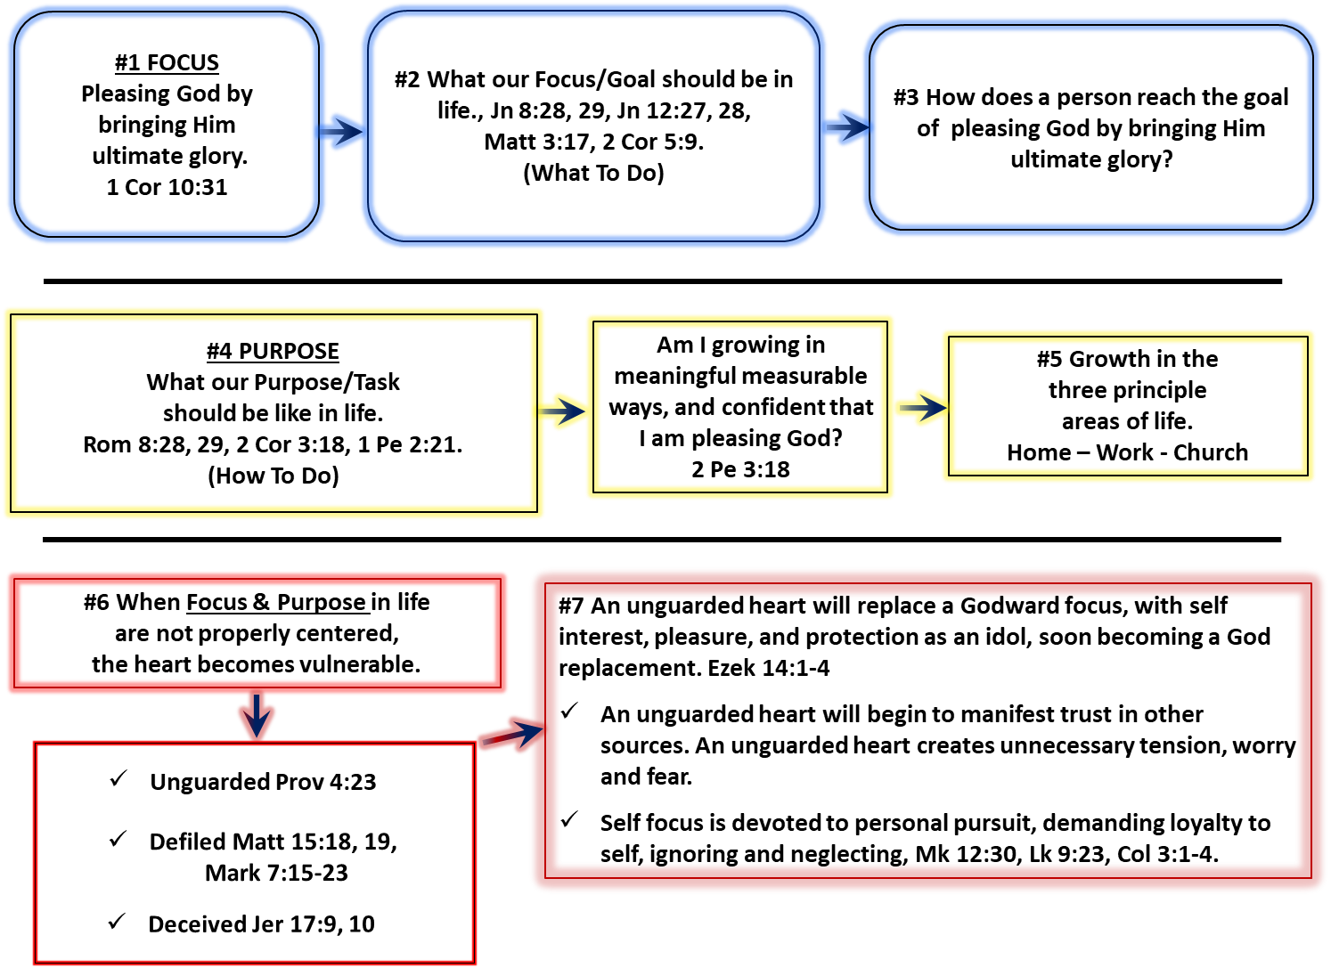

Further explanation of reaching the goal of pleasing God by bringing Him ultimate glory is found in this chart. Starting at “me”, the gray arrow going upward represents progression of growth in Christ, God’s purpose for every believer. As the believer becomes progressively more like Christ, He pleases God and brings Him ultimate glory. Growth in Christ occurs in the three principal areas of life we all live. (Romans 8:28, 29)

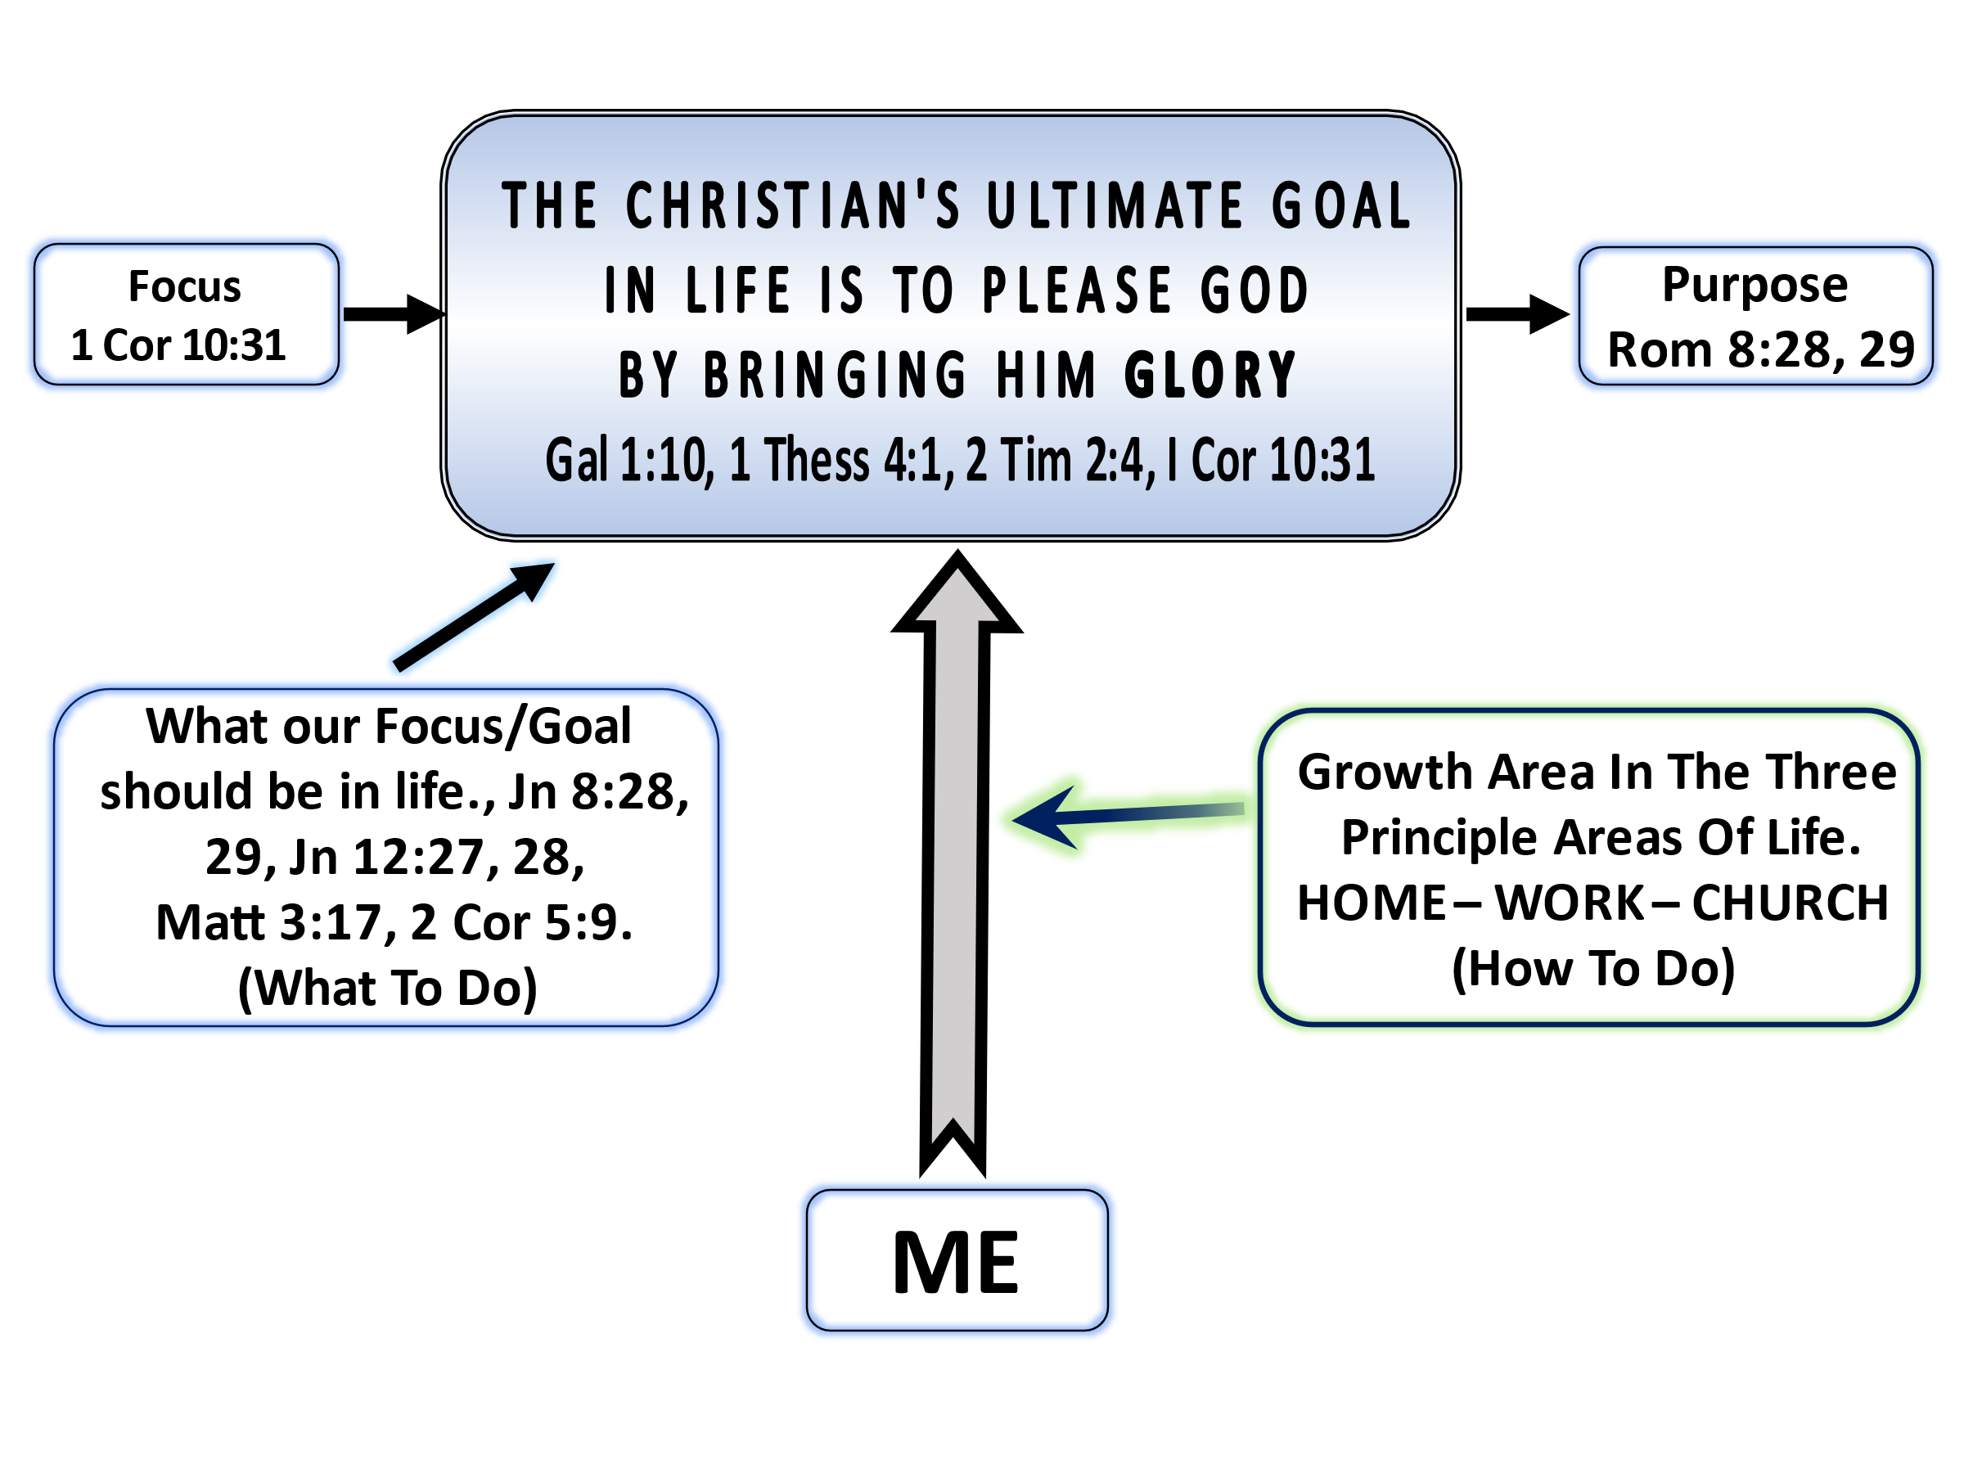

You are free to distribute this paper as a homework assignment or use its contents for other useful means, as long as it is not altered, and credit is given to the author Brad Hilgeman. https://christinyoucounseling.com
Brad Hilgeman, Bible Study Made Simple.docx,
The Top 8 Things People Desperately Desire But Can't Seem To Attain. Kathy Caprino, Forbes Magazine, May 24, 2016, Updated Dec 06, 2017
Jay E. Adams, Critical Stages of Biblical Counseling
Jay E. Adams, Godliness through Discipline.
Milton Vincent, A Gospel Primer for Christians, Day 5 Transformed by glory.
Ibid, Day 31 To Him be the Glory.
John MacArthur New Testament Commentary, 1 Corinthians
John Piper, Desiring God.
Lou Priolo, Teaching People to Please God. The Journal of Modern Ministry Vol 4, #1, 2007. Adapted from: Pleasing People: How Not to Be an Approval Junkie, Presbyterian and Reformed Publishers
Brad Hilgeman, 5c Change or Application 1.docx
Brad Hilgeman, 8 Getting to the Heart.docx

